# Space Game Idea Proposal

Starting point: The user will start with very little knowledge of what to do within reason, They will start with obvious parts of the fact they are an astronaught, that is alone, That has Two bars on the bottom right, One With “O2” Written on it and another with “Propellent”, In obvious bars showing that they are going down.

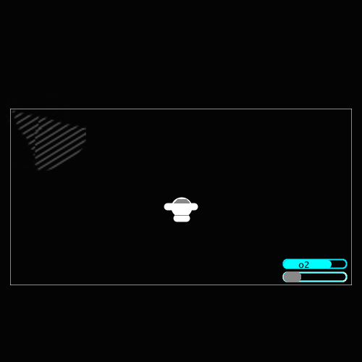

# The Puzzle

To Survive, Each Breath uses Oxygen, The more the player moves, the faster the oxygen gets used up, If this oxygen gets used to 0% then the player will die, and will be given a Death animation of sort, End game, Start over.

The Same with propellent, If a user runs out of propellent, If Option A they have oxygen, they can resource manage, via a window of sorts, and change out oxygen to get more propellent, This allows the user to carry on exploring and getting more Oxygen bottles to keep progressing.

The player will have a camera following them, outside of the players original view will be broken pieces of ship, which in each, can be a journal, to find out what the player was or who. What happened. Etc, There may also be a Oxygen Tank, this allows the player to fill up on oxygen to progress further and carry on learning about what happened.

Accessing the ships I cannot think of a puzzle/test to open the doors, Maybe a Logic puzzle like a suduko of sorts, or wordsearch. Not sure. Maybe a memory Test Puzzle, where for each door they have to remember patterns that are displayed and then repeat them, This goes into the concept of not having any memory, If they take to long they are risking running out of of 02, and it would add that extra challenge.

The player Will need to follow the radio signals to find the missing ship parts to learn and survive.

To stop the player finding the ship parts in the wrong order, we could separate them in such a distance/way they could not get there with the oxygen they had, Also if they do try and just go off the map. They can, Just once they run out of O2, or propellent they will die and get the game over screen and their charcter will float off in the distance.

I made some images in photoshop while I had some spare time, as I’m not very good at wording stuff from my head sometimes, so I thought a actual media representation would be helpful. The white thin square is what the player will see fullscreen.

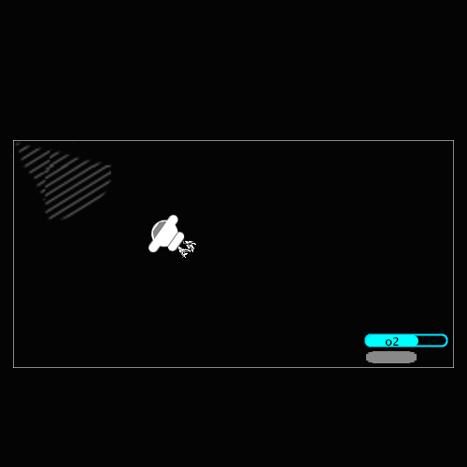

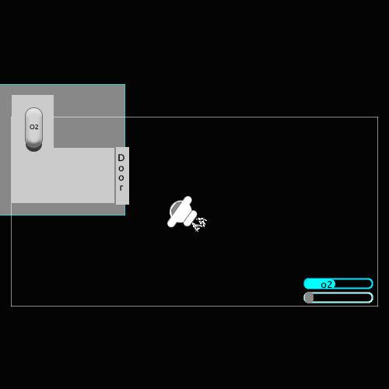

# Learning loop.

Give a few vague instructions at the start, Asking the player to move forward, Once the game has registered the player is moving forward then move back, Left and right. That’s movement, point out that the O2 and Prop Goes down when moving and doing stuff, with arrows pointing at the bars and the text for all this can be put in the narration box at the bottom.

Then possibly, guide the player through the first ship chunk, guide them through the door unlock puzzle, once in, Point out the Journal, get them to pick it up, and read it, or read the narration at the bottom of the journal, Then pick up the O2 tank and then wish them on their way.

This can all be done, by hitting Event objects in unity that trigger pop ups and timers that stop prop, O2 and movement changing while the player is being spoken too, or taught techniques to survive.